Bowmore Primary School – Child Protection Guidance
Child Protection Co-ordinator – Head Teacher , Maureen Macdonald

WHY CHILD PROTECTION?
Every child has a right to be protected from any situation or practice which may result in harm. Everyone has a responsibility to protect children. Their welfare is of paramount importance and we should work together to ensure that they are protected.

IDENTIFYING CHILD ABUSE
In order to protect children and young people from abuse, all those working around children and their families should have some understanding of child protection issues and be confident in the recognition of, and response to child abuse. Abuse and neglect are forms of maltreatment. Abuse and neglect may involve inflicting harm or failing to act to prevent harm. Children may be maltreated at home, within a family or peer network, in care placements, institutions or community settings. Those responsible may be previously unknown or familiar, or in positions of trust. They may be family members. Children may be harmed pre-birth.
Children may experience -
- Physical abuse
- Emotional abuse
- Child sexual abuse
- Neglect
- Criminal exploitation
- Child trafficking
- Female Genital Mutilation
- Forced marriage

Physical Abuse
Physical abuse is the causing of physical harm to a child or young person. Physical abuse may involve hitting, shaking, throwing, poisoning, burning or scalding, drowning or suffocating. Physical harm may also be caused when a parent or carer feigns the symptoms of, or deliberately causes, ill health to a child they are looking after.
Things to look out for –
- Unexplained Injuries (bruising, bruised eyes, fractured or broken bones, burn or bite marks)
- Perplexing illnesses
- Continuous “accidents”
- An unlikely (or no) explanation for an injury
- A continual pattern of accidents or injuries
- A child may be reluctant to change for physical activities at school etc.
- A child who is very reluctant to return home
- A child who appears withdrawn / in pain or discomfort
- A child who is resistant to going home with one family member
- Self harm, self destructiveness
- Persistent aggression and violent play

Emotional Abuse
Emotional abuse is the persistent emotional neglect or ill treatment that has severe and persistent adverse effects on a child’s emotional development. It may involve conveying to a child that they are worthless or unloved, inadequate or valued only in so far as they meet the needs of another person. It may involve the imposition of age or developmentally inappropriate expectations on a child. It may involve causing children to feel frightened or in danger, or exploiting or corrupting children. Some levels of emotional abuse are present in all types of ill treatment of a child; it can also occur independently of other forms of abuse. It can also involve children seeing or hearing the abuse of another (Domestic Abuse (Scotland) Act 2018).
Things to look out for –
- Child is developmentally delayed
- Child indicates through the use of words and body language that they think they are worthless, stupid or unattractive
- Children expect blame and punishment (or blame themselves)
- Children may harm themselves
- Children may find it difficult to make friends and see themselves as not being likeable
- Children may be mistrusting of adults
- Low self esteem
- Sudden speech and language difficulties
- Significant decline in concentration
- Head banging or rocking
- Compulsive stealing (from parents/carers/teachers)
- Extremes of passivity or aggression
- Running away
- Indiscriminate friendliness

Sexual Abuse
Child sexual abuse is any act that involves the child under 16 in any activity for the sexual gratification of another person, whether or not it is claimed the child consented or assented. Sexual abuse involves forcing or enticing a child to take part in sexual activities, whether or not the child is aware what is happening. The activities may include physical contact, including penetrative of non-penetrative acts. They may include non contact activities, such as involving children in looking at, or in the production of, pornographic material or in watching sexual activities, using sexual language towards a child or encouraging children to behave in a sexually inappropriate ways.
Child sexual exploitation is a form of child sexual abuse. It occurs where an individual or group takes advantage of an imbalance of power to coerce, manipulate or deceive a person under 18 into sexual activity in exchange for something the victim wants or needs, and for the financial advantage/increased status of perpetrator. It can also occur through the use of technology.
Things to look out for –
- Highly sexualised behaviour, rather than affectionate physical contact
- Abused children may express their worries and experiences through play
- Sexually explicit paintings or drawings
- Sexual knowledge or curiosity (unlikely for their age)
- Children can tell you unhappy secrets or games that they are uneasy about
- Regression in development
- Self harm
- A child not wishing to go with a certain adult or be looked after by a certain person
- Pain, itching or redness in the genital or anal area
- Bruising, bleeding or soreness in any orifice

Neglect

Neglect is the persistent failure to meet a child’s basic physical and /or psychological needs, likely to result in the serious impairment of the child’s health or development. It may involve a parent or carer failing to provide adequate food, shelter and clothing, to protect a child from physical harm or danger, or to ensure access to appropriate medical care or treatment. It may also include neglect of, or failure to respond to, a child’s basic emotional needs. Neglect may also result in the child being diagnosed as suffering from “non-organic failure to thrive” where they have significantly failed to reach normal weight and growth or developmental milestones and where physical and genetic reasons have been medically eliminated. In its extreme form children can be at serious risk from the effects of malnutrition, lack of nurturing and stimulation. This can lead to serious long-term effects such as greater susceptibility to serious childhood illnesses and reduction in potential stature. With young children in particular, the consequences may be life threatening within a relatively short period of time.
Things to look out for –
- Child may be too thin
- Child may be tired and lethargic
- Child may arrive at your workplace desperate for food/constantly hungry, eating large amounts
- Child may be regularly dressed inappropriately for the weather
- Clothes may be dirty, smelly or soiled
- Parents may not bring the child on a regular basis
- Frequent lateness and/or unexplained non-attendance at school
- Child / young person may have untreated medical conditions or infections
- Low self esteem
- Ask: are all the children in the family neglected or is it only one child/ young person?

Criminal Exploitation
Criminal exploitation refers to the action of an individual or group using an imbalance of power to coerce, control, manipulate or deceive a children or young person under 18 into any criminal activity in exchange for something the victim needs or wants, or for the financial or other advantage of the perpetrator. Violence or a threat of violence may feature.

Child Trafficking
Child trafficking involves the recruitment, transportation, harbouring or receipt, exchange or transfer of a children under the age of 18 for the purposes of exploitation. It can be within an area and not necessarily across borders.

Female Genital Mutilation
This involves the partial or total removal of the external female genitalia, or other injury to the female genital organs for non-medical reasons. These procedures are a criminal offence in Scotland.

Forced Marriage
A forced marriage is a marriage conducted without the full and free consent of both parties and where duress is a factor. It is both a child protection and an adult protection matter. It may be a risk alongside other forms of so-called ‘honour-based’ abuse.

ROLES & RESPONSIBILITIES OF AGENCIES INVOLVED WITH CHILD PROTECTION
Child protection refers to the processes involved in the consideration, assessment and planning of required action, together with the actions themselves, where there are concerns that a child may be at risk from harm. All agencies working with children and young people have a shared responsibility for protecting children and young people and safeguarding their welfare. The Getting it right for every child (GIRFEC) approach underlines how services operate.
Educational Services has a role within child protection to identify children and young people who may be victims of abuse. In this role school staff need to be aware of signs and symptoms of abuse. They should observe carefully the behaviour and demeanour of children and young people and, when approached, take time to listen. Any concern or suspicions the teacher might have, no matter how trivial they may seem at the time, should be recorded in consultation with Head Teacher. The HT is also the names person for children in school. Where a specific concern is noted as a child protection issue the HT will take the appropriate action, e.g. contact Social Work Service or Police.

DEALING WITH A CHILD PROTECTION CONCERN
In school staff have significant day to day contact with children and therefore, they are able to contribute to contribute to the assessment of children in need of protection.
It is important that practitioners recognise that children and young people are harmed or are at risk of harm from those people who are supposed to care for them. If you are concerned about a child but unsure whether they are being abused, simply discuss your concerns the Headteacher or, if HT is unavailable, the Principal Teacher.
If a child / young person tells you someone may have abused them;
DO
- Stay Calm
- Listen to the Child
- Keep questions to a minimum
- Reassure Child
- Record what the child has said in their own words

DON’T
- Ask too many questions
- Make false promises
- Express shock or anger
- Delay in passing on your concerns
- Confront or discuss allegations with perpetrator
- Worry you might be mistaken
- Assume information is unimportant

NEVER
- Carry out an investigation into an allegation this is NOT your role.

MAKING A REFERRAL
Once you have discussed your concerns with the Head Teacher, she may decide to pass on your concerns to Social Services or the Police.
You will require share the following information:
- Child’s name, address and date of birth
- Parent’s address and current whereabouts
- Where the child is and their views where known
- Your details
- Your involvement with the child
- What are your concerns
- Details of alleged abuse
- Whether there are any other children in the household
- Whether the parents / carers are aware of your concerns

Keep a written, dated note of any concerns using the child’s exact words. This information will be required in any investigation and staff must co-operate with, and assist Social Work, Police and other relevant agencies in the Child Protection process. When Social Services receive concerns about a child this initiates an assessment of whether the child is in need of protection. The HT will be involved in a multi-agency discussion – an Initial Referral Discussion – involving Social Work, Police, Health and Education.

Further guidance can be obtained from Standard Circular 3.23 (in the school office or online) and the Port Ellen Primary School Child Protection. There are also a number of self learning modules that can be accessed from the Argyll & Bute Council page.

EQUAL PROTECTION FROM ASSAULT
Equal protection from assault is the law in Scotland under the Children (Equal Protection from Assault) (Scotland) Act. It affords children the same protection from assault as adults and disallows physical punishment of children by parents/carers. There is no ‘reasonable chastisement’.

A parent or carer assaulting a child in any way will be a crime and therefore should be reported to the Police. If such an assault is witnessed by you or reported to you, you should report this to HT who will establish the circumstances and see if this is an isolated issue or part of wider child protection concerns.

DOMESTIC ABUSE AND ITS INFLUENCE ON CHILDREN
Domestic abuse can involve physical abuse, sexual abuse, emotional abuse including controlling behavior. The Domestic Abuse Act recognizes psychological harm and coercive and controlling behavior. The legislation also recognises the impact of domestic abuse on children.

Staff should be alert to patterns of behavior that indicate coercive control and controlling behaviours and be aware of the victim’s levels of fear and the impact of this on them and their children even when victims may have difficulty articulating the abuse and what they are afraid of. Again, any concerns should be raised with the HT in the first instance. The case may be referred to a Multi Agency Risk Assessment Conference (MARAC) where all relevant information is shared and an action plan made.

Where there is any Police involvement or incidents of domestic abuse which could impact on children, this information will be shared with the named person who will consider the needs of the children and put appropriate support in place.

- Information about the Act on gov.scot .
- Information about the Act on mygovscot: Smacking and children - mygov.scot
- A dedicated page about the Act on Parent Club: Guide to the law about physically punishing a child | Parent Club
- Promotional materials about the Act: Children (Equal Protection from Assault) (Scotland) Act 2019: promotional materials - gov.scot (www.gov.scot)
- An easy read factsheet about the Act: Children (Equal Protection from Assault) (Scotland) Act factsheet: easy read version - gov.scot (www.gov.scot)

Useful Links for staff

National Guidance for Child Protection in Scotland 2021 - updated 2023 - gov.scot (www.gov.scot)

Childline Primary Posters English (nspcc.org.uk)

Training is mandatory for ALL staff and can be accessed on LEON
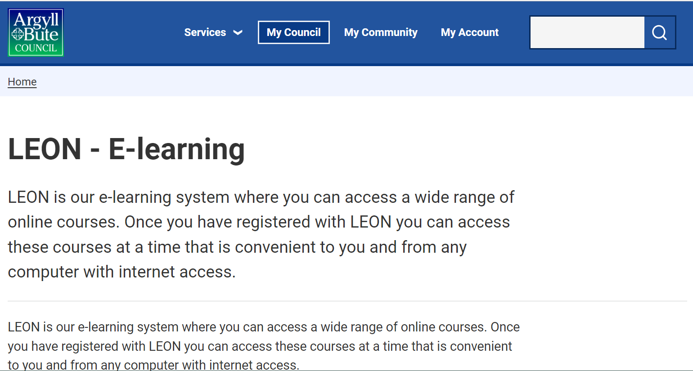

Useful Links for Children

CEOP – Child Exploitation and Online Protection
A safe and secure place to report if you have been a victim of sexual online abuse or you’re worried this is happening to someone you know. Many sites have the report to CEOP button.
www.ceop.police.uk

Childline
Advice for children and young people to help keep safe online and to know what to do when things go wrong.
www.childline.org.uk
Telephone: 0800 11 11

Thinkuknow
A website featuring films, learning activity and information to help young people keep themselves safe from sexual abuse and exploitation
www.thinkuknow.co.uk

Useful Links for parents

Support & advice for parents | NSPCC

Talk PANTS & Join Pantosaurus - The Underwear Rule | NSPCC

