Argyll and Bute Council: Customer Services: Education
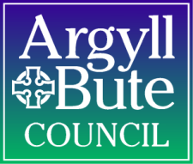

Annual Standard and Quality Report 2018/19

Establishment | 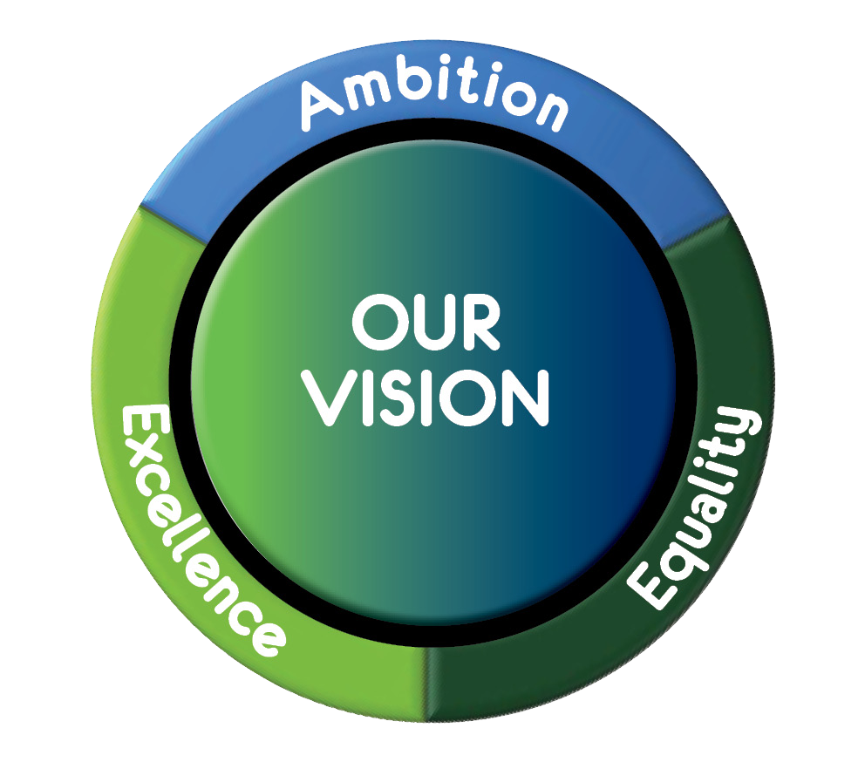  Bun-sgoil Bhogha Mòr (Bowmore Primary School)
Area | MAKI

CONTENTS

- Our Establishment Context
- Our Vision, Values and Aims
- Summary of our Self Evaluation Engagement Process
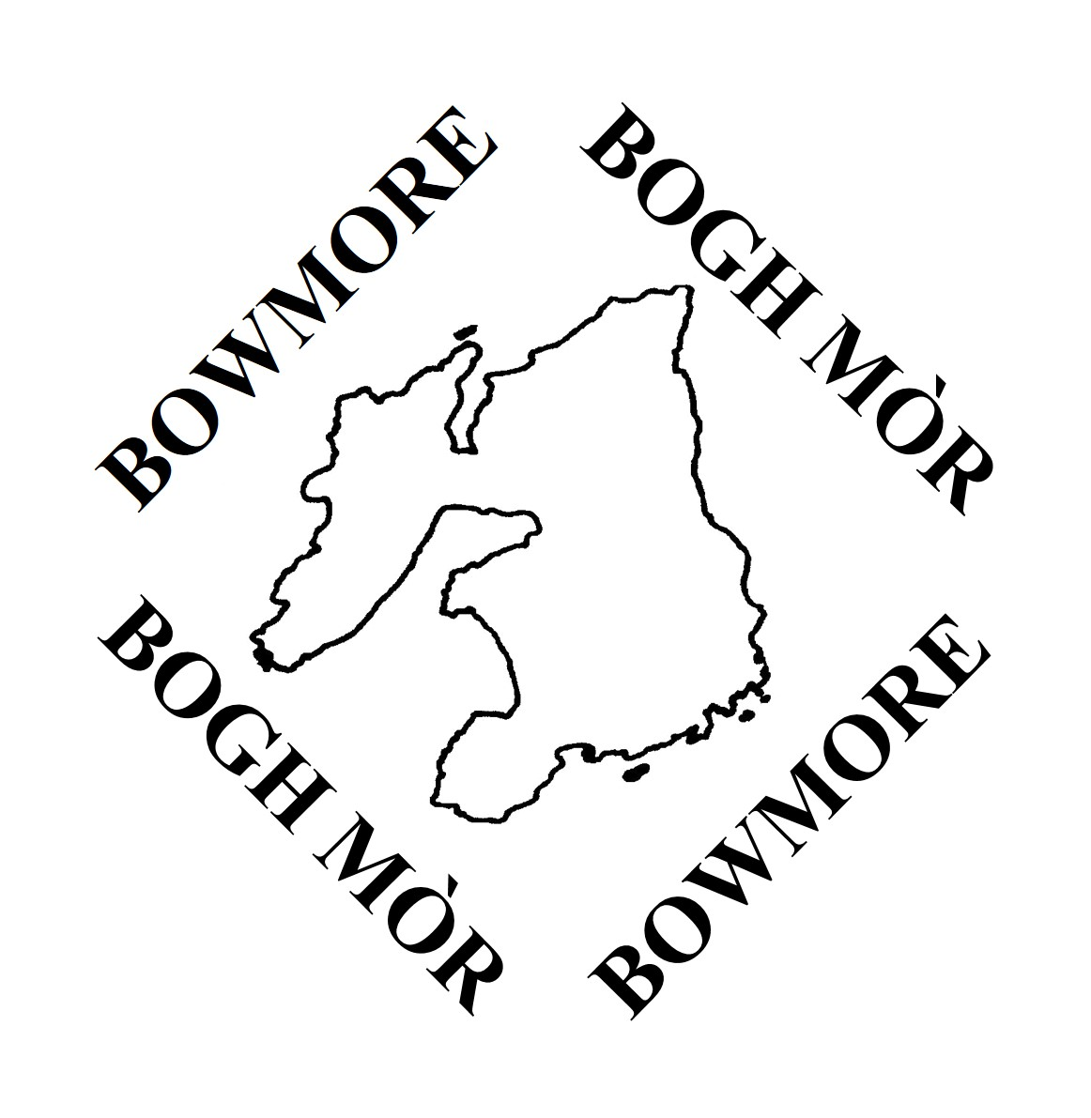
- Review of our Progress for Session 2018-2019

SIGNATURES

Head of Establishment |  | Date | June 2019
Education Officer | Simone McAdam | Date | June 2019

1. Establishment Context
The School

Bowmore Primary School is a non-denominational and co-educational school providing Gaelic Medium Education from 3-12. There are 3 classes in English Medium – P1/2, P3-5, and P6/7 with a combined roll of 56. The English ELC operates from 9am -3pm daily for 3 and 4 year olds. Bowmore ELC is also registered to accommodate 2 yr olds.
There are 2 Gaelic Classes, one is an Early Level Total Immersion class attended by children from Sgoil-Àraich to P3 with a combined roll of 12 and P1-4 in the afternoon (7). The Immersion Gaelic Medium class is P4-7 am (10) and P5-7 pm (8).
The SIMD (Social Index of Multiple Deprivation) decile for the area of Bowmore ranges between 4 and 7. This calculation is based on income, employment, education, housing, health, crime, and geographical access within the area.

Staffing

The F.T.E. (full time equivalent) teaching compliment for the school this session is 6.25. This figure is determined by the number of pupils enrolled in the school in Gaelic and English Classes and the shared headship arrangement between Port Ellen and Bowmore Primaries. The school has 1 PT teachers and a shared acting PT. Both PTs work with staff to continuously develop the curriculum and to support the School Improvement Agenda. Teaching staff take responsibility for developing an aspect of the improvement plan. The school has 0.8FTE Pupil Support Teacher Time . The PST has responsibility for supporting all children who require further input, reinforcement and consolidation in their learning.
The staff configuration is as follows;

English Medium
- P1/2- Miss MacCaskill
- P3-5 Ms McKerrell
- P6/7 Miss MacArthur
Gaelic Medium
- Early Level Class/ P1-4 – Miss Alexander
- P4-7/P5-7 – Miss McPhee

Pupil Support Teacher
- Alice Stewart

EM Nursery
- Angela Small
- Dionne MacKerrell
- Laura Woodrow
- Classroom Assistant – Marion Heads
Sgoil-Àraich
- Sophie Ferguson
- Classroom Assistant – Heather Hope

The school has a history of forming strong links with Gaelic and Scottish history and culture and the school Gaelic choir is strong and competitive. The school reached the finals of the Scottish Education Awards for Gaelic 2017/18 after the implementation of the Early Years Class which was seen as innovative practice.
The school also benefits from having an AMF – Assessment moderator facilitator and a SSERC Mentor.

Scottish Attainment Challenge

Every council area is benefitting from Pupil Equity Funding (PEF) and 95% of schools in Scotland have been allocated funding for pupils in P1-S3 known to be eligible for free school meals. This funding is to be spent at the discretion of Head Teachers working in partnership with each other and their local authority.
In order for us to ensure that our PEF Funding is utilised to meet the needs of our learners and to gain maximum impact we engage with the Education Endowment Fund Learning and teaching toolkit. This enables us to ;
- Ensure our work supports the aspirations of the Scottish Attainment Challenge.
- Look at ways the poverty-related attainment gap be addressed across the school and cluster?
- Ensure an effective approach in our setting to involving parents and carers in reducing the poverty-related attainment gap.

Session 2018/19 Pupil Equity Funding £4680

During the session 2018/19 through the self-evaluation process, we agreed as a staff and in collaboration with the Parent Council and Pupils
to focus on;

- Raising Attainment in Reading
With our PEF we purchased the following ;
- Accelerated Reading – Renewed Subscription
- Purchased Sumdog Reading , Spelling and Writing
- Sets of Novels to challenge good readers
- Phonics based reading books
  - Magic Belt
  - Talisman
  - Dandelion
- Material to support Dyslexia
- Games and puppets to support spelling, listening and talking

- Raising Attainment in Numeracy
We have piloted SEAL (Stages of Early Arithmetical Learning ) and have used PEF Funding to purchase resources to;
- support counting,
- resources to enable 1:1 support e.g. Power of 2, Plus 1,
- teacher’s resources for SEAL.

- Use of Digital Technologies to enhance learning and teaching
We are at the beginning of our Digital Awards journey. Much work has yet to be done – see new SIP. We have augmented our hardware by
And purchased;
- 3 ipads to augment and increase our supply to 13.
- Apps to support numeracy and literacy.

Our targeted approach for intervention in 2017/18 was for those children who are highlighted as having social, emotional and behavioural
Difficulties as evidenced through a Boxall Profile. The focus of intervention is;

- Metacognition and Self-Regulation
- Behaviour Interventions

We completed our Better Movers and Thinkers Training for staff and parents carried out by Dr Andy Dalziel in August 2018
To Raise Attainment in literacy and numeracy staff also
- Engaged in moderation activity , literacy , numeracy , social studies, science
- Engaged in Digital technologies in-house training
- Used assessment Data to inform further planning and intervention

Staff and the parent council have been included and consulted in the planned universal and targeted interventions of the school for 2019/20.
See separate PEF action plan for this year.

2. Our vision, values and aims
Bowmore Primary is in the unique position of providing Gaelic Medium Education in Argyll and the only primary school on Islay with this provision. Our Curriculum Rationale is displayed at the front of the school and clearly illustrates our ethos of inclusion and equity. This is in the form of a tree. The Rationales for both English Medium and Gaelic Medium Education have been documented and disseminated to stakeholders. The Gaelic Medium Rationale was reviewed and updated this session to align with the key components of the National Gaelic Plan.
The school values were agreed in collaboration with children, staff and parents. These are:

- Respect
- Inclusion
- Persevere
- Excellence

In Gaelic this is :
- Sàr-mhaitheas - Excellence
- Urram – Respect
- In-Gabhail - Inclusion
- Leanaltas - Perseverance

Through the principles of our vision and values we aim:
- to provide a happy, caring and safe environment where creative, effective teaching and learning can take place and where mistakes are made in the effort to try new things and become successful.
- For parents and staff work closely together to help children learn, achieve and celebrate their personal best.
- To respect and value differences in people in Bowmore, Islay and our world.
- To continue to get better at being an Eco School and to develop positive attitudes to the environment and towards our health and wellbeing.
- To enable staff to function happily, professionally and effectively by promoting an ethos where their work is valued and respected.
- To continue to maintain good relationships with other schools, agencies and the community by supporting and being involved in joint ventures, sharing information, ideas and expertise

The Gaelic Medium Education Curriculum differs from English Medium as there is a focus on acquiring vocabulary and developing fluency in the language. Our Rationale in Gaelic includes the following;

Aithris Rùin / Mission Statement
Gaelic language and culture is at the centre of learning in Bun-Sgoil Bhogha Mòr. We aim to maximise the skills and capabilities of each child, nurturing them to become confident in the Gaelic language.
Experiences - We provide the highest standard of education and care for our children, ensuring they receive a range of high-quality experiences while also following their interests; promoting their curiosity, inquiry and creativity. These experiences will support the development of good communication skills in Gaelic.
Environment - Learning takes place in a safe, happy, stimulating and welcoming Gaelic rich environment which sets high expectations for literacy and the use of the Gaelic language. We aim to create an environment where Gaelic is valued and used at all times.
Interactions - Staff are important role models for our children enabling them to hear and absorb high-quality Gaelic through daily interactions. As children play and learn, staff work alongside and interact with children to enable them to develop their knowledge and skills in the Gaelic language, with emphasis on developing social language so children begin to speak Gaelic for real and purposeful reasons.
We recognise that Gaelic is the responsibility of all, and that learning does not take place in the classroom alone, therefore children, staff, parents and the wider community will work closely in a partnership based on mutual respect and support.

Amasan/ Aims of Gaelic Medium Education at Bun-sgoil Bhogha Mòr

- Acquisition;-To help children acquire skills in speaking, listening to, reading and writing the Gaelic language so they can communicate effectively.

- Usage; To ensure the children are motivated to use their Gaelic and support them in developing their confidence in a range of social settings.

- Corpus;- To create a Gaelic rich environment where the quality of Gaelic used is of a high standard.

- Status;- To create a positive ethos of respect towards Gaelic, ensuring it is seen and heard throughout the school and the local environment .

Our curriculum and our plan for improvement reinforces the key objectives contained within the Argyll and Bute’s Education vision and strategy Our Children Their Future which are to;

- Raise educational attainment and achievement for all
- Use performance information to secure improvement for children and
young people
- Ensure children have the best start in life and are ready to succeed
- Equip young people to secure and sustain positive destinations and
achieve success in life
- Ensure high quality partnership working and community engagement
- Strengthen leadership at all levels

Our school improvement plan compliments and reinforces the work being taken forward by the school and the local authority to deliver improving outcomes for all our learners.
The four key priorities of the National Improvement Framework are considered and included when developing our plan. They are
:
- Improvement in attainment, particularly in literacy and numeracy.
- Closing the attainment gap between the most and least disadvantaged children.
- Improvement in children's and young people’s health and wellbeing.
- Improvement in employability .

- Summary of our self-evaluation engagement process

Participants | Engagement Details
Staff (teaching and non-teaching) | Staff work jointly with other cluster schools and because of the shared HT arrangement, they work closely with staff from Port Ellen Primary. This year teaching staff from both schools engaged in joint self-evaluation and planning activities. The staff in Gaelic Medium Provision meet at Local Authority level at various times throughout the year. The new SIP reflects this.  Joint actions are highlighted in PURPLE  ELC Improvements are highlighted in BLUE.  Specific Actions for GME are highlighted in GREEN  Self – Evaluation among teaching and non-teaching staff is carried out using;  The PRD process is used to determine next steps and self-reflection.  Professional dialogue and peer evaluation and monitoring.  Using national documents such as HGIOS 4 & HGIOELC, Building the Ambition, The LAD Framework, Gaelic Medium Curriculum – The Principles  GTCS, Professional Standards  SSSC Code of practice  All staff Professional learning is linked to the Improvement Strategy and self-evaluation. For teachers this is built into the working time agreement. There is a strong focus on moderation, across curricular areas and also on pedagogy.  Staff from both schools including GME from Bowmore have built up trust and a level of professionalism to engage in critical evaluation in order to improve.
Parent Council and Comunn Nam Pàrant | Regular meetings with the Parent Council and with Comunn nam Pàrant members enables parents to be well informed of developments within the school.  Parents engage with documents such as the Parent Involvement Strategy and this is used as a benchmark for practice within the school.  The Parent council seek the opinions of parents and provide feedback to the HT.  Parent Questionnaires are issued as part of our ongoing self-evaluation strategy.  Parents across the school including Pre 5 are represented on the council.  Parents are involved in the life of the school and we have a well-established ethos promoting equity and inclusion. This provide an opportunities for parents to support improvement.  The Parent Council have a Facebook Page open to all parents. This is governed and monitored by the Council members and School Information is shared with parents, sometimes suggestions made are fed back to the school, normally from the secretary to the HT and Chair.  There is a strong fundraising drive which has been of great benefit to the school in terms of resources for outdoor play and technology. The parent council and comunn nam pàrant hold several events over the session. They are also a presence at whole school events such as pantos, summer fair, sports day.  Microsoft Forms are beginning to be used as a means of gaining opinions, ideas from parents- such as internet safety. Staff are becoming more confident to use forms and this type of communication will be used more next session.
Pupils | The Pupils are very active within the school. There are opportunities throughout the session for pupils to take on a leadership role. This can be as;  Captains/vice captains of their school house Otters, Golden Eagles and Red Deer  Changemakers Groups,  Endeavour  Leading clubs.  Eco Monitors  Nursery Monitors  School assemblies provide the children with a forum for seeking the opinions of their peers.  The Captains meet with staff at pupil council meetings and disseminate information, seek guidance and plan for improvement.  All children have a learning Log which provides information of learning and achievement as well as engaging children in self-evaluation of progress.  Data of progress in literacy and numeracy is Uploaded on Seemis annually however tracking is robust and regularly updated using our in-house tracking system.  The children participate in school evaluation and Microsoft forms have been used this session to enable pupils to share their evaluations of internet safety and assess their digital skills. This form of evaluation will be used by teaching staff and CCEWs more next session.
Volunteers working in school | Any volunteers are welcome to provide verbal feedback to staff. There are many ways of communicating their opinions, evaluations;  Via the school’s Twitter Account  On the School Website.  Through direct communication with staff and the HT.  Using the PC Facebook Page.
Community Partners | There are well-developed links between the service and other relevant childcare services, schools and agencies such as health and social work services in the local area and in the wider community.  Partners understand and appreciate the different contexts in which we work and value the range of expertise our learners can benefit from.  All partners invest significant time and energy to establish and build positive sustainable relationships. Engagement and communication between partners is regular, structured, supportive and efficient.  Partners are involved in aspects of school development, helping to drive forward improvements. Through professional dialogue and discussion we seek input from our partners.  Partners meet with staff, pupils and parents and are involved in improving outcomes for our children and evaluating the service we provide.  All partners demonstrate commitment to improving outcomes for learners.
Local Cluster | As a Cluster our joint improvement planning enables us to monitor and track progress, determine what is working well and identify what we need to do to improve.  Our rigorous approach to moderation, transition, assessment and joint planning e.g. literacy and numeracy, use of holistic assessment, STEM, digital technologies and languages, enable staff to share standards and collaboratively drive forward developments to raise attainment across the curriculum.
Local Authority | Quality Assurance school visits provide guidance and structure around School Improvement and identified priorities.  Professional dialogue around school data , OCTF and NIF drivers provided a focus for school improvement.  Evaluative discussions are focused on driving improvement and informative about current policy/initiatives/opportunities. .  Bowmore Primary’s ambitions and School success is shared and celebrated with the EO. Engagement with the EO also provides challenge enabling the HT to self-reflect and raise expectations.  Children’s progress in literacy and numeracy is tracked on Seemis at P1,4,7 and the EO and HT discuss pupil progress from data contained in our in-house tracking.  The Early years provide questionnaires to gain feedback from parents.  The developmental milestones are tracked and monitored for 2, 3 and 4 year olds.  LAD visits take place twice a year and feedback inform future areas of focus.  Staff attend training within the LA which informs aspects of school improvement.  The Management Team inform HTs of priorities for development and this is disseminated to school staff.  HT meetings are held several times a year including shared HT meetings. The content of the meetings is closely linked to the LA Business Plan.  The LA consult with HTs and Parent Councils about new policy and strategies (when appropriate.
Overall impact of stakeholder engagement | Bowmore Primary school community is involved in ongoing self-evaluation which enables us to be a reflective school.  The pace of change is quick and school developments reflect the direction the school is taking.  Staff, pupils, partners and the community strive to make the school the best it can be.  Our inclusive approach to Self-evaluation empowers stakeholders and helps to raise confidence about the school within the community.  There are high expectations for improvement from all within the school community of Bowmore.  The school recognises that all stakeholders who make up Bowmore School Community have an impact on children’s learning and lives and their contribution is valued greatly.  Our vision is underpinned by our values and aims and working together with parents, partners and the Education Service not only supports us to enable our children to reach their full potential but also to deliver school improvements most effectively.

4. Review of Progress for Session 2018-2019 – Leadership and Management

OCTF | NIF DRIVER | NIF PRIORITY | HGIOS?4 - QI 1.3  Leadership of Change – Themes:
- Raise educational attainment and achievement for all  - Use performance information to secure improvement for children and young people  - Ensure children have the best start in life and are ready to succeed  - Equip young people to secure and sustain positive destinations and achieve success in life  - Ensure high quality partnership working and community engagement  - Strengthen leadership at all levels | - School Leadership  - Teacher Professionalism  - Parental Engagement  - Assessment of children’s progress  - School Improvement  - Performance Information | - Improvement in attainment, particularly in literacy and numeracy.  - Closing the attainment gap between the most and least disadvantaged children.  - Improvement in children and young people’s health and wellbeing.  - Improvement in employability skills and sustained positive school leaver destinations for all young people. | - Developing a shared vision, values and aims relevant to the school and its community  - Strategic planning for continuous improvement  - Implementing improvement and change
Establishment Priority – Leadership of Change
Progress and Impact:
- Digital Strategy
- Updated strategy Include updates technology benchmarks and Es&Os in policy, refer to A&B digital strategy and national digital strategy in policy as well as cluster strategy.
- Increased teacher confidence around skills – 3 Twilight sessions took place throughout the year averaging at 77% attendance. 100% of staff indicated an improvement in skills and knowledge. Survey available
- Jo Clark trained GME teachers of Robotics for P7 GME Transition
- Bowmore Primary are working towards the Digital Schools Award. – Jo Clark and Linsay MacArthur carried out an audit and created an action plan for the school moving forward it’s digital agenda (see SIP)
- Increase pupil knowledge and understanding of internet safety – 100% of children participated in internet safety learning and completed the pupil survey. Class teacher Feedback highlighted Concerns about children’s knowledge of internet safety and cyber resilience. Questionnaire available

- Increase digital literacy among pupils – establish baseline of skills level August 19, track progress June 20-20. Complete digital skills passport to recognize digital skills-
- Cross Cluster P7 Transition was digital based – The focus was on Robotics where children used programming skills.
- Review and upgrade estate- increased ipads by 23% in English and 500% in GM and purchased digital Bluetooth microphone and speaker system

- Staff Development
- 100% of engaged in the following mandatory training /developments within the school session. Training up to date and to be carried out annually.
  - GIRFEC
  - Child Protection
  - Health and Safety
  - Fire
  - GDPR
  - Risk Assessments
- 100% Teachers and CEWs attended at least 1 CPD off island training event.
  - Emergent Literacy Training for P1 Teachers – impact on expectations, planning, resources to support literacy in Early Years, progression pathways in E1-3 literacy . Clear Joint Session Planning
  - SEAL training – impact on whole school and nursery numeracy planning, resources to support numeracy, clear progression. SEAL strategies now planned as part of everyday activities in ELC
  - SSERC Training – creation of Science homelink bags to be implemented 2019/20, staff training
  - Storyline Training – increased confidence to use the approach in IDL
  - Robotics Training – impact on GME and EM P7 transition . Increased teacher confidence as a result of training.
  - Wild Things Outdoors Training – To drive learning in ELC next session. Increased enthusiasm, motivation and confidence
  - Getting Ready for Two Year Olds - Increased staff confidence in planning around milestones and developing play and language skills
  - Play in ELC – increased staff knowledge. PT to lead in ELC and Sgoil Araich next session
- 80% Teaching staff attended planned twilights for ;
  - Digital support
  - Better Movers Thinkers
  - STEM- cross cluster
  - L1+2
  - Talking Mats
  - Moderation

- 70% staff (teachers, ASN, C/As, CEWs) to attend ASD training.
  - Feedback led to parent support group being set up across Islay (Facebook group)
- HT to attend Leadership Training – Excellence in Headship
  - Increased Knowledge and understanding of Leadership in terms of Critical Self-Awareness
  - Networking opportunities with HTs outwith A&B

- Early Level Pedagogy

- Early Level tracking updated for Literacy and Numeracy. P1 CT part of A&B working group
- 50% staff engaged in Play based learning training and cascaded information to CCEWs in Port Ellen. Layout of ELC room changed to include more structured literacy and numeracy play stations.
- Almost All children made expected progress in Lit/num/dev milestones throughout the Early Level this session.
100% 4yr olds on track in Maths and Numeracy and Literacy
63% 3yr olds on Track Maths and Numeracy and Literacy
100% 3yr old boys on track , 63% 3yr old girls on track
100% 3 and 4 yr olds on track in Gaelic Medium Education
- Emergent literacy is implemented and joint session learning reflects this.
- All Nursery Tracking is now online – aligned with P1-7 Tracking and put on to shared drive.
- Successful Implementation of 1140hrs
- Pupil Leadership
- Pupil Voice heard across all levels through meetings with staff, led by pupil council
- Increase in engagement in lunchtime clubs ran by pupils
- Endeavour projects – increase in pupil leadership,
- Pupils meeting with parent council to help run fundraising events and to decide on new resources for the outdoor area
- Implementation of the National Gaelic Plan
- Increase in EM parents attending bingo fundraiser
- 100% of children attended Colluim Cille trip to Ireland . Children formed future networking opportunities with pupils from Gaelsgoil in Ireland.
- PT/HT attended 2 day training in Gaelic
- PT and CT part of Polaar working group – assessments to be implemented in August 2019
- CTs part of working group (LA) to create progression pathways in literacy
- Parent Evening not well attended, need for rethink
- Implementation of Seachdainn na Gaidhlig which provided excellent opportunities for pupils to develop a wide range of skills (within 4 capacities) . School formed good links with Spòrs Gaighlig , CNaG, ICCI
- Bowmore Primary ran cluster bilingual Orienteering event attended by PEPS and PCPS thus reinforcing language learned in L1&2 plan
- Increase in use of Twitter to promote Gaelic Learning
- Increase in technology hardware
- Robotics was main focus of transition
- Increase from 13% to 33% fluent speakers attending National Mòd in Glasgow 2019
- Wild Things Outdoors Training carried out by CCEW

Next Steps
- Digital Strategy – see SIP 2019/20
- Staff Development;
  - Columba 1400 – next session
  - With Autism Network Scotland there has been a decision to create an Autism, Dementia Aware Islay . Stages to be implemented with
    - partners , parents and businesses 2019/20
  - Wild Things Outdoors Training – To drive learning in ELC next session. Increased enthusiasm, motivation and confidence
  - Digital Learning to become part of transition process
  - Nurture – Clear 3 year plan working towards Nurturing Schools Award, increased knowledge among staff, implementation of Nurture Groups, clear pupil evaluations, increased emotional literacy among children. – Priority to continue next session.
  - New Management Structure to be in place next session with the appointment of a Shared PT

- Early Level Pedagogy
- New LAD Framework to be implemented
- Management and Monitoring of ELC to be taken over by PT. Regular monitoring to ensure play is purposeful.
- Staff PRD to focus on CPD to increase creativity and engaging play.
- Staff to be more familiar with National Documents such as HGIOELC and redeveloped Building the Ambition document. Principles and Practices to be embedded in planning and practice
- Shared Practice with Port Ellen to be reintroduced.
- Outdoor play to drive learning and 60% of learning to take place outdoors
- Increase Parental engagement in line with A&Bs Parent Engagement strategy
- Pupil Leadership
- Pupil Evaluations carried out using Microsoft forms
- Pupils to become familiar with HGIOURS, use for evaluation
- HT in consultation with pupils make child friendly SIP
- Changemaker groups to develop action plan and meet weekly

- Implementation of Gaelic Plan
- Stay and Play sessions once a week to be implemented in Sgoil Araich from October
- Extra 2 hrs weekly literacy and numeracy support for children in GME 4-7
- CCEW in Sgoil Araich to lead Outdoor Learning
- Trip to Sabhal Mòr Ostaig and Spòrs Camp 2020
- Continued Technology focus for transition

4. Review of Progress for Session 2018-2019 – Learning Provision

OCTF | NIF DRIVER | NIF PRIORITY | HGIOS?4 - QI 2.3  Learning, Teaching and Assessment – Themes:
- Raise educational attainment and achievement for all  - Use performance information to secure improvement for children and young people  - Ensure children have the best start in life and are ready to succeed  - Equip young people to secure and sustain positive destinations and achieve success in life  - Ensure high quality partnership working and community engagement  - Strengthen leadership at all levels | - School Leadership  - Teacher Professionalism  - Parental Engagement  - Assessment of children’s progress  - School Improvement  - Performance Information | - Improvement in attainment, particularly in literacy and numeracy.  - Closing the attainment gap between the most and least disadvantaged children.  - Improvement in children and young people’s health and wellbeing.  - Improvement in employability skills and sustained positive school leaver destinations for all young people. | - Learning and engagement  - Quality of teaching  - Effective use of assessment  - Planning, tracking and monitoring
Establishment Priority – Learning, Teaching and Assessment
Progress and Impact:
- Joint School IDLs

- Pollination Project
- All children N1- P7 participated in working with the Islay Wildlife trust.
- Learning linked across social studies, numeracy and maths, IT and expressive arts.
- Children linked learning to Plastics IDL. This was Islay Wide.
- Children created pollination habitats and increased understanding of life cycles.

- Dunyvaig
- Children across all levels participated in real life archaeological dig with Reading University and Islay Heritage.
- Children at Early level linked learning to Castles – great technology created.
- Linked learning across social studies, expressive arts , IT, literacy and numeracy
- Good examples of across cluster moderation science, numeracy, literacy.
- Benefits building confidence in NAR process, what progression through the levels looks like, designing good LI SC and learning experiences.
- Increased understanding among staff about holistic assessments. Good joint school discussion.
- Opportunity for upskilling children’s iT skills. Timetabled so that Second level children from other schools participated in IT tutorials with Jo Clark
- Plastics Project
- Bowmore reporting to authority on their moderation progress as a good example.
- Port Ellen staff and children skype with the Marine Trust in Hawaii and the Maldives. Did comparative study. Very motivational experience.
- Storyline Approach (1st level) for plastics topic was carried out.
- Staff from Port Ellen and Bowmore primaries met regularly to discuss progression and moderation led to increased understanding of progression and holistic assessment
- Good international link led to sharing of learning with parents - plastics assembly,
- Local impact – increased beach cleans and awareness of the damage of plastics on local environment.
- GME ICT from info from beach clean on Excel, top group percentages, graphs on Glow debate and balanced writing,
- Scottish link to Burravoe school,
- Collecting of data using Microsoft forms with parents
- posters encourage single use plastics persuasive writing and children wanted to have a voice and speak out,
- Letters to Ileach
- Holistic Maths: CTs found the following;
- Jo struggled to measure with assessment numeracy skills, just looked at information handling skills
- Arlene found problem solving bit tricky and was a bit hard, however was successful at including numeracy skills, struggled putting working out down,
- Maggie-numbers big for counting for wee people, not any numeracy, struggled with scale so supported scale for P1 and 2, could answer simple questions on the bar graphs, 2 and 3 used excel,
- Morven sorted plastic, tallied and totalled, added up the totals, different types of numeracy questions, top group converted into a percentage, put in excel,
- Kirsty did not do numeracy bit like Jo and Maggie, answered ‘how many more?’ questions, p2 -4 did practice on making a chart on word but too complicated,
- Rachael did the sorting in the playground and in groups, had to sort the materials did a graph but not enough materials so a bit easy as all were able to manage, had to count the total, all managed so needs more challenge,
- Kate homework task to find plastic in the home and took survey and made into table and graph, some up the levels used excel,
- Literacy- Did not have time to go over literacy assessments, but all felt confident they achieved what they had set out to do and the assessments measured the learning intentions and success criteria well. Range of debates, posters, persuasive writing, balanced arguments
- Conclusions: The topic was very successful for children having a range of motivating learning experiences. Technology was successfully used in a variety of ways- google meets, infographics, book creators, pages and excel. Literacy experiences were valid and linked well to Es and OS. More difficulty with numeracy though. Some made to easy, or did not have enough numeracy in the design, it was difficult in that the numbers were difficult or there was too much to cover and it was too long.

- Storyline Approach

- 100% of first level class teachers attended training and delivered 1 IDL using this approach.
- CTs report greater depth in learning , particularly linking literacy to another subject area- see above re plastics
- GME used Storyline approach for their trip to Ireland – CT reported increased depth of learning.
- CT reported much better understanding of the NAR
- CTs at first level engaged in evaluative discussion and contributed feedback to moderation discussion.

- SSERC

- Maggie Harrison/ Rachel MacCaskill to developed a series of STEM Homelink bags for all the cluster schools. A total of 71 bags were put together from Early to Second Level, trying to cover all curriculum organisers. (See Phase 1 Bags – next page )

List of Homelink Bags for PEPS, BPS, PCPS

Early | First | Second
Investigating Forces | Investigating Chemical Reactions- Volcano | Investigating Chemical Reactions – Lava lamp
Investigating Light & Shadow | Investigating Dissolving | Investigating Magnets
Investigating Magnets | Investigating Forces – balloon rocket | Investigating Friction – hovercraft
Investigating Minibeasts | Investigating Friction – car ramp | Investigating Materials – hydrophobic sand
Investigating Ponds | Investigating Minibeasts | Investigating Biodiversity
Investigating Sounds | Investigating Sounds & Vibration

List of Homelink Bags for KPS, SIPS

Early | First | Second
Investigating Forces | Investigating Sounds & Vibration | Investigating Chemical Reactions – Lava lamp
Investigating Ponds | Investigating Dissolving | Investigating Biodiversity
 | Investigating Forces – balloon rocket | Investigating Friction – hovercraft
Investigating Minibeasts | Investigating Friction – car ramp

- Presented Homelink bags at CPD event for staff. (Rachel had the evaluation forms)
- Successful application for Kickstart Funding for British Science Week to supplement the Homelink Bags in Port Ellen. Awarded £300, resulted in a further 20 bags being made, with enough materials for a few more. We have a baseline and will measure impact over next year.

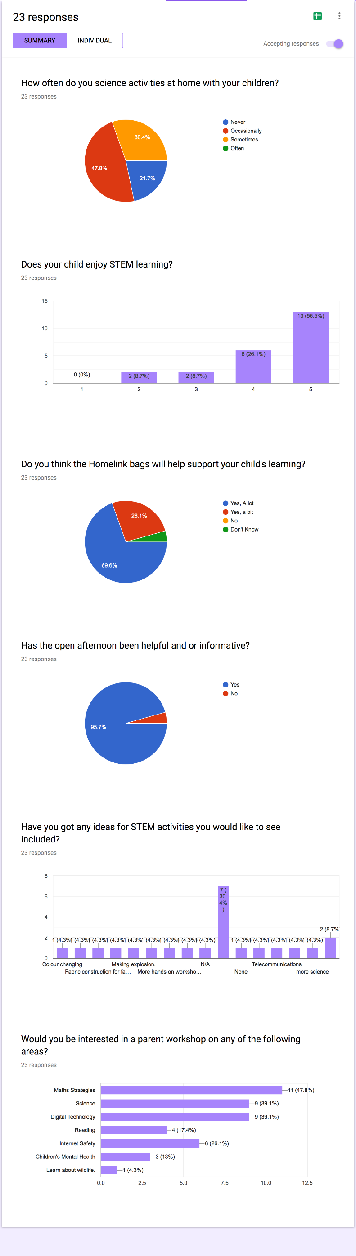
- Science Day organised and held for parents during National Science and Engineering Week. Launch of STEM Homelink bags. Positive response to the Open afternoon and the STEM Homelink Bags. (See screenshot of feedback)

- Participated in the Primary Science Education Conference, Edinburgh in June 2019 along with BPS. Presenting learning on marine plastics. This project incorporated topical science, maths and technologies (STEM) and was used to moderate learning in these subject areas in PEPS and BPS.

L1+2
- The transition class took part in a Gaelic Comic project where the children helped to create a published comic about using a local legend. Professional Comic artists and writers came into school to help with this.
- Gaelic is encouraged to be spoken in Bowmore Primary School through daily instructions and basic conversations on topics such as the weather in every class and throughout all stages. This exposure enables everyone to participate in listening to and speaking Gaelic words and phrases, increasing confidence and familiarity of a second language.
- Teachers have been attending one Gaelic CPD every term with Mrs MacLennan from Port Charlotte Primary. This has increased teachers confidence in classroom daily instructions etc.

Next Steps
Moderation
- New SIP – Moderation to be included in Key Objective 1
- Transition to be included in the moderation plan
- Robust Cluster Plan in place
- Dates and Venues agreed by cluster HTs
- See SIP
IDLs – session 2019/20
- Make tasks challenging, but not overly long or complex to attempt.
- Agreed might be better to work on designing a bank of simple tasks in a loose context that require children to solve problems cold across different organisers, and this will be priority.
- We will discuss assessment formats, achievement of a level and joint moderation plans for next year at the inservice day.
- IDLs tied into Moderation next SIP
- First Level to design an holistic task

STEM
- A&B to release money to allow us to resource a series of STEM boxes for ELCC linked to stories .
- To run CPD on this.
- Try and get more STEM into ELCC.
- Get the Homelink bags up and running

L1&2

- Learning Gaelic in context of heritage of Islay so strong Links to Gaelfest Ile Community event (song and Poetry) Key Objective 4 in SIP 2019/20
- Gaelic Moderation to be carried out in Term 1 and 3
- Linked to IT
- Regular timetabled Gaelic Bookbug sessions in Pre 5 to be organised
- Ensure that all teachers across the Northern Alliance see themselves as teachers of language - Develop moderation work across primary and secondary schools. Track teaching and progress of language
- Add Value to developing the young workforce ensuring languages are within Developing Young Workforce agenda across the northern alliance - link language experiences in school to the wider community for English classes as well as Gaelic Classes
- Drip Feeding Gaelic into the classroom/school so the children get used to using the language.
Twilights - Gaelic

- Go Gaelic topic areas
- Go Gaelic Resource - Topic Areas
- Talking Pen, linked to talking dictionaries
- Teaching of words and the language
Twilights - French

- Power Language Platform
- Grow Story Grow - videos of topic ideas
- Apps to support languages such as Puppet Pals/ Sock Puppets/Chatterpix.
- Cultural Appreciation discussion with feedback of resources

Learning and Teaching
- Focus on moderating Learning Intentions and Success Criteria
- Time put into year calendar for Peer class visits and observations
- (this will be included in the moderation plan- key objective 1 )

4. Review of Progress for Session 2018-2019 – Successes and Achievements

OCTF | NIF DRIVER | NIF PRIORITY | HGIOS?4 - QI 3.1  Ensuring Wellbeing, Equity and Inclusion – Themes:
- Raise educational attainment and achievement for all  - Use performance information to secure improvement for children and young people  - Ensure children have the best start in life and are ready to succeed  - Equip young people to secure and sustain positive destinations and achieve success in life  - Ensure high quality partnership working and community engagement  - Strengthen leadership at all levels | - School Leadership  - Teacher Professionalism  - Parental Engagement  - Assessment of children’s progress  - School Improvement  - Performance Information | - Improvement in attainment, particularly in literacy and numeracy.  - Closing the attainment gap between the most and least disadvantaged children.  - Improvement in children and young people’s health and wellbeing.  - Improvement in employability skills and sustained positive school leaver destinations for all young people. | - Wellbeing  - Fulfilment of statutory duties  - Inclusion and equality
Establishment Priority – Ensuring Wellbeing, Equity and Inclusion
Progress and Impact:

  - Health and Wellbeing Fund – Report to Date, Eat Well for Less Project

- £2000 funding awarded from Argyll and Bute Health and Wellbeing Fund
- Teacher met to agree on Experiences and Outcomes to be taught, activities and assessment. We focussed on Health and Wellbeing and Food Technologies. Holistic assessment was agreed.
- The topic was introduced to Primary 7 who then researched and sourced the equipment needed to carry out the learning. Five mini hobs / ovens were then ordered along with 5 sets of utensils, pots and pans, aprons for a class and other cooking equipment. £987.27 was spent at this stage.
- Each class then learned about healthy eating using current advice creating healthy eating plans or meals and even suggesting healthy packed lunch options. All children then learned about cleanliness, hygiene and safety when preparing food.
- Following on from this, each class used their newly learned knowledge to prepare and cook healthy snacks and meals. Primary 1 made healthy snack for a few weeks which was sold to the whole school or given to ELCC, Primary 2/3/4 made dips and dippers and Primary 5-7 made a variety of meals and snacks to share at home which included pitta pockets, spicy chickpea hotpot and sausage casserole.
- Each child in the school then completed an Holistic Assessment (incorporating Literacy, Technologies and Health and Wellbeing) tailored to their learning. This showed us the learning which had taken place.
- We are now at the final stage of the project for this year. Primary 7 have selected a meal in their group which is cheap, healthy and simple to make, using what they have learned. This week, family members have been invited in and the P7 children will lead a Cook Along each day where they show their parents how to make their chosen meal.

- Total Spend to date - £1346.55 ( Compost to grow own produce and food purchased for each class and ELC and for Cook Alongs)
- 35% of parents have so far agreed to come to our Cook Along sessions but not all slips have been returned so this may increase.

- Approaches to supporting chn with ASD– Autism Network Scotland (2 Days)
90% of practitioners to participated in ASD training
100% of staff who participated in staff training report increased confidence in accessing services for children with ASD and increase in knowledge and understanding
Further ‘Keeping Staff Safe’ Training delivered by Elaine Ross . This was seen as a need as a result of the audit
100% practitioners implement at least 3 strategies within the training- identified in consultation with individual parents and noted on UCPs
Reduction in incidences of violence and PERS 100 forms sent to central team,

- Implementing Nurture Groups
- PT and ASN run weekly Nurture sessions using strategies to enable children to talk, think about behaviour , react , resolve conflict
- All children attending Nurture were assessed using the Boxall assessment and then reassessed at the end of term 4 (recently) Please see info below.
- Lego Therapy and individual Coaching sessions using strategies to increase emotional literacy
- Moving forward as a school, Amy Hannett Port Ellen has developed a clear 3 year plan for Nurture and H&W which will be used in BPS.
- Children attending Nurture have built up trust and respect for Gillian Morris and Marion Heads and engage positively in individual sessions. This has impacted positively on their engagement in class and on their learning.
- Nurture has been so successful that it will be a key priority next session.
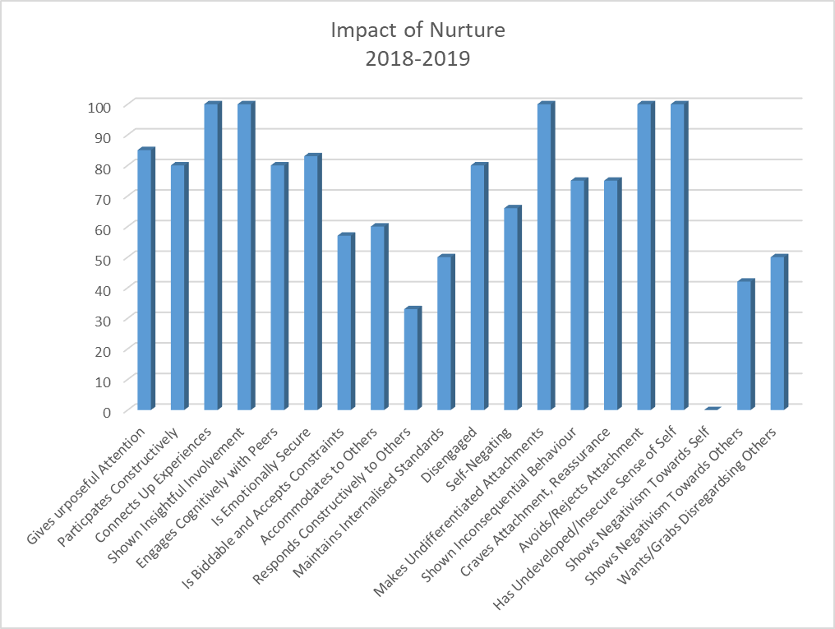
Percentage of children showing an improvement in targets

Next Steps
- Eat Well for Less
- Continue to encourage parental engagement
- We hope to collate all recipes made throughout the school then ask for parental contributions to create a Bowmore Primary school Eat Well For Less Recipe Book.
- Increase the amount of produce we grow ourselves to ensure Healthy Food Education is sustainable in Bowmore Primary School.
- ASD Training with Autism Network Scotland. - Stages of creating an autism/dementia aware area
See SIP Key Objective 5
- Stay and Play GME – Sgoil –àraich
See SIP plan KEY OBJECTIVE 3 AND pef PLAN

4. Review of Progress for Session 2018-2019 – Successes and Achievements

OCTF | NIF DRIVER | NIF PRIORITY | HGIOS?4 - QI 3.2  Raising attainment and achievement – Themes:
- Raise educational attainment and achievement for all  - Use performance information to secure improvement for children and young people  - Ensure children have the best start in life and are ready to succeed  - Equip young people to secure and sustain positive destinations and achieve success in life  - Ensure high quality partnership working and community engagement  - Strengthen leadership at all levels | - School Leadership  - Teacher Professionalism  - Parental Engagement  - Assessment of children’s progress  - School Improvement  - Performance Information | - Improvement in attainment, particularly in literacy and numeracy.  - Closing the attainment gap between the most and least disadvantaged children.  - Improvement in children and young people’s health and wellbeing.  - Improvement in employability skills and sustained positive school leaver destinations for all young people. | - Attainment in literacy and numeracy  - Attainment over time  - Overall quality of learners’ achievement  - Equity for all learners
Establishment Priority – Raising attainment and achievement
Progress and Impact:
SEAL
- Rachael MacAskill and Kirsty Alexander participated in a working party to merge the Early Level benchmarks with the LAD framework.

Emergent Literacy
English Medium – Impact
- Graphs clearly show progress over the session.
- Notable lack of scissor skills and pre writing skills in ELCC- planning and environment reviewed to include these skills and enable children in ELCC to practise everyday.
- Gaps identified in ELCC
Emergent Literacy
- Participated in Emergent Literacy Pilot
- Increased focus on pre reading, writing skills
- Joint sessions with ELCC – focus on Emergent Literacy Skills
- Maggie Harrison, Rachael MacAskill and Kirsty Alexander all participated in review of literacy in LAD Framework

Phonological Awareness & Fine Motor Screen Results
Primary 1 BPS English 2018-2019

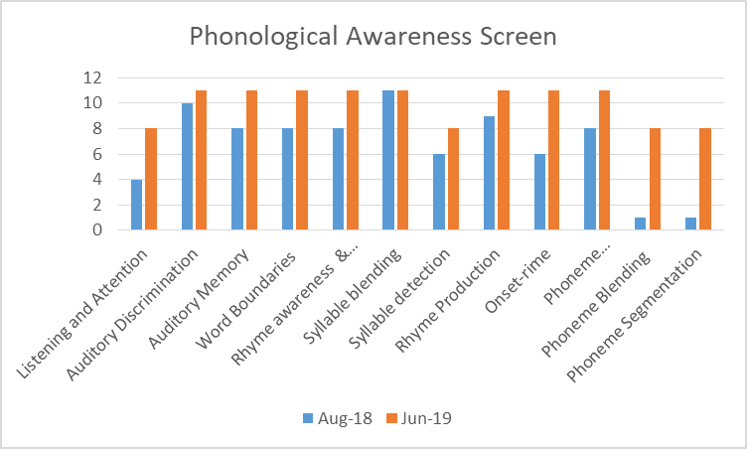
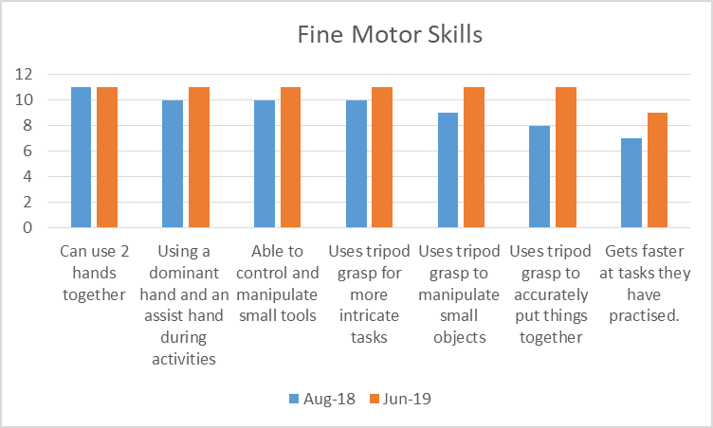

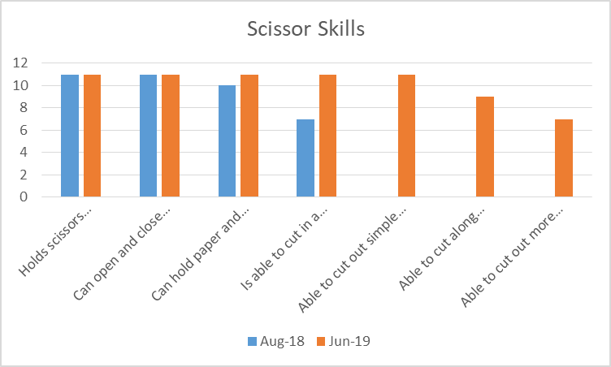
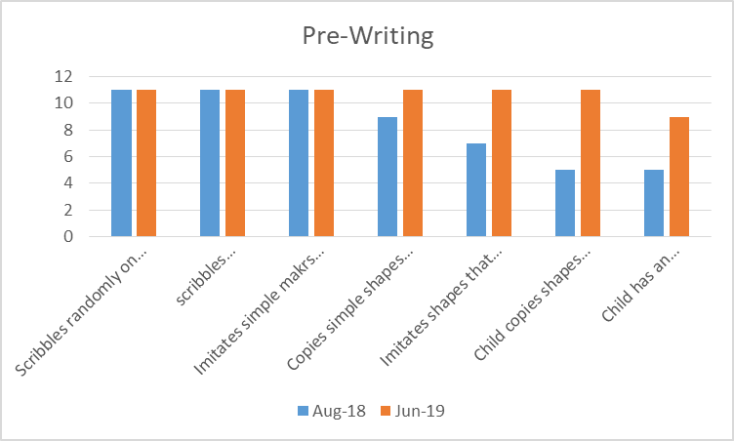

Phonological Awareness & Fine Motor Screen Results Primary 1 BPS Gaelic 2018-2019

Bowmore English Literacy and numeracy Tracker P1,4,7
Bowmore English - Numeracy and Literacy
 | Numeracy |  | Listening & Talking |  | Reading |  | Writing
 | 2018 | 2019 | 2018 | 2019 | 2018 | 2019 | 2018 | 2019
P1 | 100 | 100 | 100 | 100 | 100 | 100 | 100 | 92
P4 | 100 | 100 | 100 | 100 | 100 | 71 | 80 | 71
P7 | 64 | 86 | 64 | 86 | 36 | 79 | 45 | 86

Gaelic
Bowmore Gaelic - Numeracy and Literacy
 | Numeracy |  | Listening & Talking |  | Reading |  | Writing
 | 2018 | 2019 | 2018 | 2019 | 2018 | 2019 | 2018 | 2019
P1 Gaelic | 100 | 100 | 100 | 100 | 100 | 100 | 100 | 92
P4 Gaelic | 100 | 0 | 0 | 100 | 0 | 100 | 0 | 0
English | 100 | 0 | 0 | 100 | 0 | 0 | 0 | 0
P7 Gaelic | 40 | 100 | 40 | 100 | 40 | 100 | 40 | 0
English |  |  | 40 | 100 | 40 | 100 | 40 | 0

Next Steps:
Literacy
- Participate in FMRC
- All classes to continue to do a novel study inc ELCC
- Create a reading strategy and policy – with BPS
- Implement new literacy and numeracy progression as per the modified LAD framework in ELCC.
See KO1 and 2 new SIP
SEAL and Numeracy
- Links to digital learning
- Shared good practice of teaching numeracy
- Moderation to include analytical view of SNSA results
- Look at area for moderation – building mindsets, applied maths, problem solving

