National Digital Learning Week 2019

Stakeholder Communications Pack

Introduction and context

National Digital Learning Week is back. This year the event will take place from Monday 13 to Friday 17 May.

For the fifth annual National Digital Learning Week we are inviting all early learning and childcare centres and schools across Scotland to take part in five curriculum focused challenges in STEM, Social Studies, Expressive Arts, Literacy and Numeracy.

How to use this Communications Pack

Our aim is to reach all early learning and childcare centres schools across Scotland to let them know about the event.

As a valued stakeholder you are invited to help us achieve this using the promotional text in this communications pack to engage with your audiences through your established Communications and Engagement channels.

In this pack you will find: key messages, suggested promotional text for websites e-bulletins and publications, social media posts, a promotional video and a promotional flyer. Please pick and choose which is most relevant for your channel and audience.

About National Digital Learning Week 2019

- National Digital Learning Week is led by Education Scotland to give pupils and practitioners the opportunity to share best practice and enhance their skills in digital learning and teaching.

- Using digital technology, practitioners and pupils across Scotland are invited to take part in five curriculum focused challenges in STEM, Social Studies, Expressive Arts, Literacy and Numeracy.

- A dedicated Glow Blog has been developed for National Digital Learning Week which includes information about the five challenges, support materials, activity suggestions and short videos. We recognise that establishments are at different stages in their digital journey, so Education Scotland has carefully developed support materials for each challenge to be inclusive of all digital abilities.

- Establishments can win Glow goodies by can sharing their digital work on the dedicated NDLW19 Glow Blog or by tagging @Digilearnscot on Twitter and using #NDLW19.

Promotional text for events sections on websites, e-bulletins, blogs and publications

National Digital Learning Week returns for 2019

National Digital Learning week is back. This year the event will take place from Monday 13 to Friday 17 May.

For the fifth annual National Digital Learning Week all early learning and childcare centres and schools across Scotland are invited to take part in five curriculum focused challenges in STEM, Social Studies, Expressive Arts, Literacy and Numeracy. To ensure all teachers are fully supported to take part Education Scotland have developed a package of materials including activity suggestions and how to guides.

Schools that share their work are in with a chance of winning some exclusive Glow goodies. Simply tag @digilearnscot on Twitter and use #NDLW19 or upload directly on the Glow Blog.

For more information and to get started with the challenges visit the National Digital Glow Blog today https://bit.ly/2PfR0Go

Promotional video

We have created a short 2 minute video promoting NDLW 2019. This includes information on the 5 challenges, the support materials and how to share activities. Please promote this video as widely as possible through your social media channels and on your website if appropriate.

Link to video:

https://youtu.be/PUummmUN8Jk

Social Media – Suggested Tweets

Tweets can be sent out from Wednesday 24 April 2019.

Please ensure you tag: @educationscot @digilearnscot and use

#NDLW19

National Digital Learning week is back. This year the event will take place from Monday 13 to Friday 17 May. Visit the dedicated Glow Blog for more. https://bit.ly/2PfR0Go #NDLW19 @digilearnscot @educationscot

@educationscot announce 5 curriculum focused challenges for National Digital Learning Week. Visit the dedicated Glow Blog for more. https://bit.ly/2PfR0Go #NDLW19 @digilearnscot

Learners can embrace their inner Computing Scientist in the STEM challenge for this year’s National Digital Learning Week. Check this out along with other curriculum focused challenges on the dedicated Glow Blog. https://bit.ly/2KWT1bX #NDLW19 @digilearnscot @educationscot

There are lots of ways to use digital tools in Expressive Arts. Find out how it’s a big part of this year’s National Digital Learning Week. Visit the dedicated Glow Blog for more https://bit.ly/2VZmy5M #NDLW19 @digilearnscot @educationscot

Did you know you can use digital tools in History Modern Studies and Geography to strengthen understanding of a topic? Take part in the Social Studies Challenge for National Digital Learning Week 2019. https://bit.ly/2XE6Ey3 #NDLW19 @digilearnscot @educationscot

Find out how National Digital Learning Week 2019 can help young people focus on a career as a data analyst as part of the Numeracy challenge. Find out how to take part by visiting the dedicated Glow Blog https://bit.ly/2KYvRSp #NDLW19 @digilearnscot @educationscot

Giants. Unicorns. Dragons. Scottish myths and legends are at the heart of the digital story telling activity for National Digital Learning Week 2019. Find out how to take part by visiting the dedicated Glow Blog https://bit.ly/2va40nq #NDLW19 @digilearnscot @educationscot

Schools that take part in National Digital Learning Week are in with a chance of getting exclusive Glow goodies for their school. Upload your work on Twitter using #NDLW19 or post directly on the Glow blog: https://bit.ly/2PfR0Go #NDLW19 @digilearnscot @educationscot

Promotional Flyer

Attached in PDF format for download or to use in social media and online platforms.

Press and Media Enquiries

For all media and press enquiries or to request an official quote

please contact mediaenquires@educationscotland.gsi.gov.uk

Further information and contacts

If you require further information or promotional materials not included in this pack please contact:

Lorna.kerr@educationscotland.gov.uk

Stakeholder Engagement Team at Education Scotland.

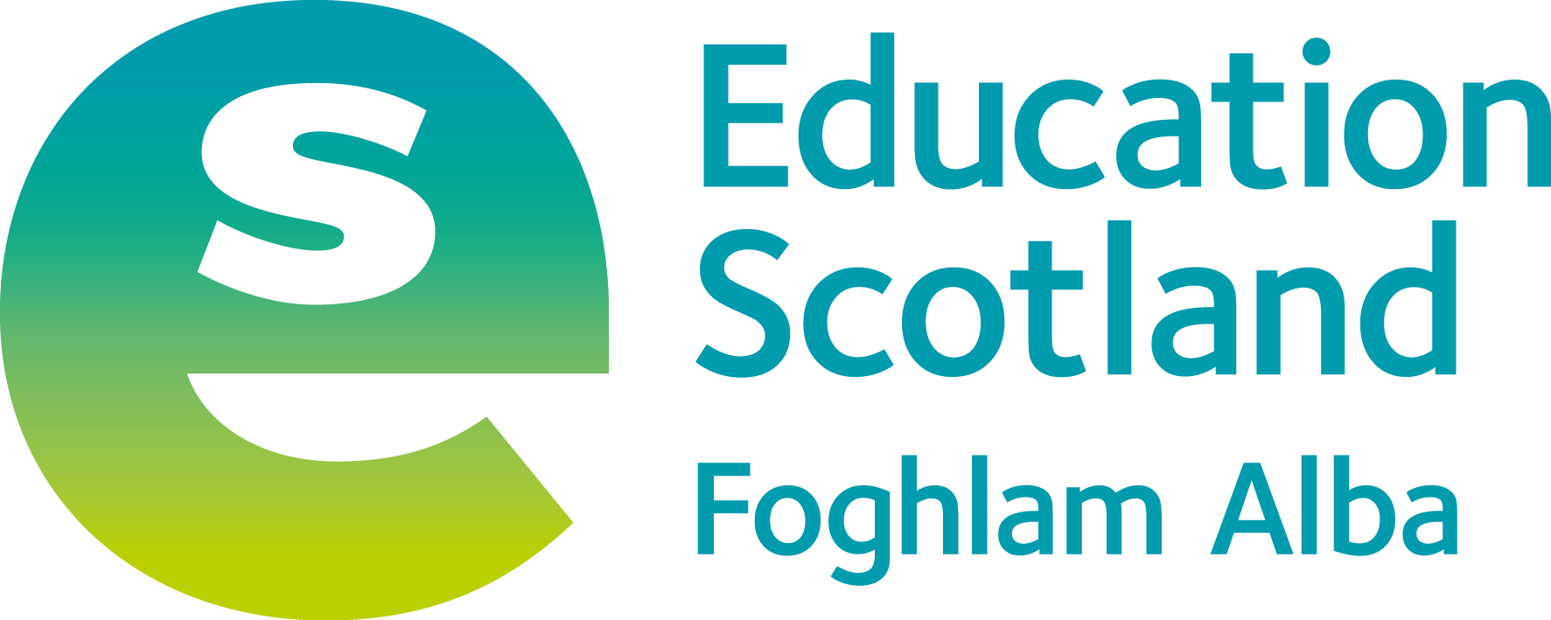
Education Scotland
Denholm House
Almondvale Business Park
Almondvale Way
Livingston EH54 6GA

T +44 (0)131 244 4330
E enquiries@educationscotland.gsi.gov.uk

www.education.gov.scot

© Crown Copyright, 2019

You may re-use this information (excluding images and logos) free of charge in any format or medium, under the terms of the Open Government Licence providing that it is reproduced accurately and not in a misleading context. The material must be acknowledged as Education Scotland copyright and the document title specified.

To view this licence, visit http://nationalarchives.gov.uk/doc/open-government-licence or e-mail: psi@nationalarchives.gsi.gov.uk

Where we have identified any third party copyright information you will need to obtain permission from the copyright holders concerned.

