Directions to Isobel Mair School – G77 6NB

Directions coming from Glasgow on M77:

- Exit M77 on Junction 4 – Newton Mearns/Stewarton
- Cross first roundabout, 2nd exit (passing Waitrose and retail park on right)
- Turn right on second round about take 3rd exit
- Continue along the road and the entrance to the school will be on your right, just after the retail park.
- Main entrance is at far side of car park

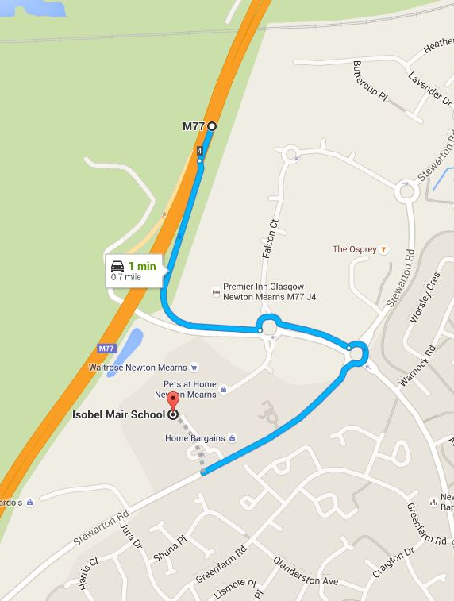
Directions from M77 towards Glasgow:

- Exit M77 at Junction 5 –A77/A726 East Kilbride/Easglesham/Newton Mearns
- At roundabout take 1st exit onto A77
- Turn right to stay on A77
- Turn Left onto Malletsheugh Road
- Turn right onto Dodside Road (B769)
- Turn right onto Aurs Road
- At roundabout take 1st exit onto Stewarton Road
- Follow road and the entrance to the school will be on your left, just before the retail park.
- Main entrance is at far side of car park