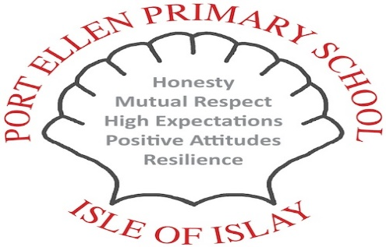
Port Ellen Primary School Parent Council
Newsletter: March 2016

The parent council have put together this newsletter to ensure all parents are keep up to date with useful information as well as an update from our recent meeting.

STAGE IN PLAYGROUND
The outdoor stage is being built to provide a place for children to perform or just play. Progress has been made within the last few months – part of the new stage has now been erected with the exception of the drums and the black boarding which has still to be added. There will also be chips laid around the stage.
The stage wood has been coated with fiber glass which will stop any maintenance needed over the coming years. The initial fiber glass panel sample was too rough and had to be remade at an additional cost to a finer spec to make it safer for the children to play. The total cost of the stage is £2280, which will be split between the school and the parent council funds.
FUNDRAISING
We will continue to sell out tea-towels and aprons. A new design and colour will be actioned this year. Lorna Millsopp will also take over the design and publishing of a school recipe book. Children , staff and Parents will be consulted in due course. Look out for requests for recipes!
SCHOOL UPDATE
Staffing
Due to cuts by Argyll & Bute Council our Clerical Staff’s hours have been decreased by 5%, Pupil Support Assistant’s decreased by 20%, while Classroom Assistants remain unchanged. ASN hours are currently being reviewed.
The Early Years department have been allocated monies and their classroom will transfer to the current P1/P2 room, and the Early Years room at present to be the new P1/P2 classroom.
The new Early Years classroom will incorporate a kitchen and this may be installed during term time next term. Parents will be informed when developments commence and the school will make every effort to keep disruption to a minimum. Any new information will be displayed on the school notice board.

NATIONAL IMPROVEMENT FRAMEWORK
The National Improvement Framework (NIF) set out our vision and priorities for our children's progress in learning, delivering both excellence and equity whilst seeking to close the attainment gap. The National Improvement Framework Priorities are;

- Improve the learning progress of every child, by reducing inequality in education
- Improvement in attainment, particularly in literacy and numeracy
- Closing the attainment gap between the most and least disadvantaged children
- Improvement in children and young people's health and well being
The following six drivers will be the focus of how to take these priorities forward. These will also be a focus of our school’s improvement agenda.
- School improvements
- Leadership
- Teacher's professionalism
- Assessments of children's progress
- Parental engagement
- Performance information data
More information about the National Improvement Framework will be given to children and to parents over the rest of the session. If parents want to discuss any of the above, please contact the Head Teacher.

Next Parent Council Meeting will be held in the school on Monday 23rd May at 6.30pm – all welcome!
Please refer to the PTG notice board located in the entrance hall for up to date members of the parent council, AGM and minutes of meetings.
If you have any questions or matters you wish to ask or to be discussed, please see a member of the parent council, attend one of the meetings, or contact us direct on:
portellenparentcouncil@btinternet.com

