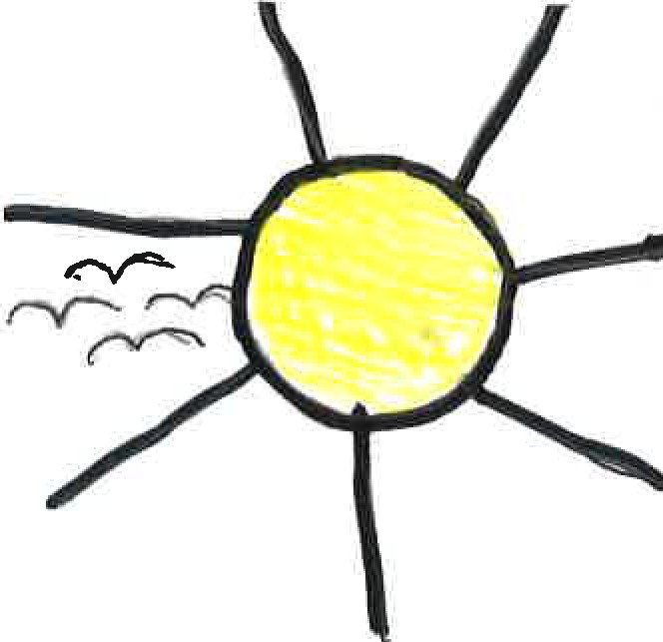
The sea brushes the sand, The sky,
The land.
The sun is a citrine The clock ticks,
Minutes pass but you want to make your time here last.
The sun sinks beneath the waves and the moon shows her silver face, The stars twinkle in the sky or maybe a shooting star going by.
The seals cry like wolves to the moon and the waves are like a soft tune. So few words for such a special place full of its remaining grace.
Tha an traigh fhathast breagha bho an Fhaoilleach gu an Dubhlachd, bho Diluain gu Didomhnaich a h-uile h-uair a thide.
Dorcha no aotrom an nuair a theid na raithean seachad sin far a bheil mo chridhe.

For this poem I used Gaelic and English. I used English because it is the first language I ever learned and Is what I use to write in all the time and feel most easy writing in. The reason I wrote in Gaelic is because it is one of the the languages people use on the place I live in and love. I also wrote in Gaelic because it was the first language of my grandfather who used to teach me Gaelic, I wrote in Gaelic to thank him for teaching me.
By Melody Elizabeth Clark-Want

